***CHAPTER 6: PLANNING PROCESSES AND TECHNIQUES***

1. PLANNING (to set a direction)

* Decide where you want to go
* Decide how best to go about it

1. ORGANIZING (to create structures)
2. LEADING (to inspire effort)
3. CONTROLLING (to ensure results)

**The planning process:**

* Should focus attention on objectives
* Create a real plan in order to accomplish objectives

1. **Define your objectives:**
2. Identify desired outcomes in very specific ways
3. Know where you want to go
4. Know how far off the mark you are at various points along the way
5. **Determine where you stand:**
6. Evaluate current accomplishments relative to the desired results
7. Know where to stand in reaching objectives
8. Know your strengths and weaknesses
9. **Develop premises regarding conditions:**
10. Anticipate future or sudden events
11. Plan alternative scenarios
12. **Analyze alternatives, make a plan:**
13. List and evaluate possible actions
14. Choose the right alternative route
15. Describe what must be done to choose the best route
16. **Implement plan and evaluate results:**
17. Take action and note progress
18. Evaluate results and revise plans

* **Good planning helps make us:**

1. Priority-Oriented: making sure the most important things get first attention
2. Action-Oriented: keeping a results-driven sense of direction
3. Advantage-Oriented: ensuring that all resources are used to best advantage
4. Change-Oriented: anticipate problems, deal with them

**Benefits of Planning:**

* Planning helps countering internal (new structures, technologies, diversity) and external (global economy, government regulations) sources that may pressure an organization.

1. **Planning Improves Focus and Flexibility**

* Knows what it does best
* Knows the needs of customers and how to serve them
* Willing and able to change and adapt to shifting circumstances
* Orientation towards future rather than past

1. **Planning improves Action Orientation**

* Stay ahead of the competition
* Work on things that only count rather than working on too many things
* Check: Good planning helps make us

1. **Planning improves Coordination and Control:**

* Efforts of each individual must add up meaningful contributions of the organization
* Combined accomplishments will advance performance
* Facilitates control
* Without it, plans and objectives may not work

**Planning and Time Management:**

* Tight schedules
* Little time alone,
* Lots of meetings and phone calls
* Optimize your time
* Make a to-do list with the right things and priorities (must do, should do, nice to do, really don’t need to do)

**Long-Range Plans:**

* Look three or more years into the future
* Top management is most likely to make these plans
* Pressure of daily events may divert attention
* Inability to anticipate, recognize and adjust to changing events

**Short-Range Plans:**

* Look less than 3 years into the future
* Smaller management employers and employees are more likely to look not too far into future
* Plans may vary daily, due to never-ending changes and events
* Even long-range plans become shorter every time

**Strategic Plans:**

* Identifies long-term directions for the organization
* Begins with a vision that clarifies the purpose of the organization and expresses what it hopes to be in the future
* Dynamic: not always what anticipated, not linear anticipation

**Tactical** **Plans**:

* Developed and used to implement strategic plans
* Intermediate-term plans
* Designed to meet a particular threar or opportunity
* Functional plans: how different components of the enterprise will contribute to the overall strategy.
* **Production** **plans**: dealing with work methods and technologies
* **Financial** **plans**: dealing with money and capital investments
* **Facilities** **plans**: facilities, work layouts
* **Logistic** **plans**: suppliers, acquiring resource inputs
* **Marketing** **plans**: selling, distributing goods or services
* **Human** **resources** **plans**: building a talented workforce

**Operational Plans:**

* What needs to be done in the short term
* Policies and procedures, used over and over again
* **Policies**: Communicates broad guidelines for making decisions and taking action in specific circumstances (ex: sexual harassment, employee performance checks)
* **Procedures**: Describes what actions are to be taken in specific situations
* **Budgets**: plans that commit resources for specific time periods to activities (useful for tracking and controlling performance)

**Planning** **Tools and Techniques:**

**Forecasting:**

* Process of predicting what will happen in the future
* Ex: China ending up having more cars than the USA (unpredictable event)
* All forecasts should be treated cautiously
* Human judgement can be wrong

**Contingency Planning:**

* Identifies alternative courses of action that can be implemented if circumstances change
* Involves thinking ahead
* Should be as certain as possible

**Scenario** **Planning**:

* Identifies alternative future scenarios and makes plans to deal with each
* Prepare for “future shocks”
* Includes worst- and best-case scenarios

**Benchmarking:**

* Use of external and internal comparisons to plan for future improvements
* Search for best practices from other people/organizations

**Goal Setting:**

* Specific: Desired outcomes clear to anyone
* Measurable: No doubt when accomplished
* Attainable: realistic, possible to accomplish
* Referred to: focused on doing better
* Timely: linked to due date and timetable

**Hierarchy of goals:**

* **Mission and purpose:** Serve the world as number one supplier
* **Top management objective:** deliver-error free products right 100% of the time (firm)
* **Senior Management:** 100% on-time production of error-free products (manufacturing division)
* **Middle Management:** Increase error-free product acceptance rate by 16%
* **Front-line Management:** Assess machine operator skills and train for error-free production

**Management by Objectives:**

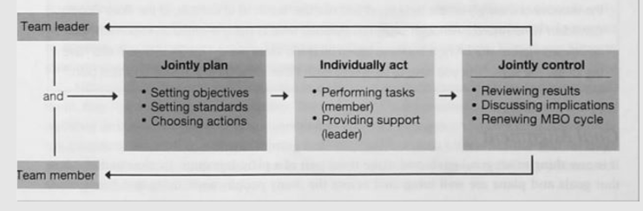

* Difficult to make performance objectives as measurable as possible
* **Relationship building:** giving people the opportunity to participate in decisions that affect their work, encourages self-management